NGP Communication Accessory Cards

Hardware Requirement Specification
Rev-B

15-May-13

Ownership Disclaimer
This document contains proprietary and confidential material that is the sole property of Compressor Controls Corporation. The information contained herein is intended for internal use by Compressor Controls Corporation employees and is not intended for distribution outside of the company. As an unpublished work of trade secrets, the recipient shall keep this document confidential. Any re-use, copying, or distribution, either in whole or in part, of this material without the express written consent of Compressor Controls Corporation is strictly forbidden.
Copyright © 2011 by Compressor Controls Corporation. All rights reserved.

Revision History

Rev. | Date | Revised By | Description
1 | 29-Mar-11 | Amith, Vinay | Initial Draft
A | 11-April-11 | Amith, Vinay | -Added surge protection for ESC card.  -Included the receive and transmit enable signals for the ESCs.  -Included magnetics to all the RJ45 connectors.  -Included the compatibility between the EEC and the EES.  -Included the EEPROM along with the EES.  -Modified the port configuration of the EES.  -Improved the clarity in the product function and specific requirement sections.
B | 15-May-13 | Manjunath Mageri | -Removed External Ethernet switch

Approvals

Approved by: Date: _______________
Approved by: Date: _______________
Approved by: Date: _______________
Approved by: Date: _______________
Approved by: Date: _______________
Approved by: Date: _______________

TABLE OF CONTENTS

1 Introduction 7
1.1 Purpose 7
1.2 Audience 7
1.3 Scope 7
1.4 Acronyms 7
1.5 References 8
2 General Description 9
2.1 System Overview 9
2.2 Product Description 10
2.2.1 Serial Accessory Card (SAC) 10
2.2.2 External Ethernet Card (EEC) 11
2.2.3 ECAT 11
2.3 Bidirectional Traceability of Requirements 12
2.4 Acceptance Criteria 12
2.5 Assumptions 12
2.6 Dependencies 12
3 Block Diagram 13
3.1 SAC MODBUS 13
3.2 External Ethernet Card 14
3.3 ECAT Card 15
4 Specific Requirements 16
4.1 Product Functional Requirements 16
4.1.1 SAC 16
4.1.2 External Ethernet Card 17
4.1.3 ECAT 17
4.2 Components 17
4.3 Connectors 18
4.4 Mechanical Specification 18
4.5 Material Specification 18
4.6 Environmental Specification 18
4.7 Schematic requirements 18
4.8 Layout requirements 19
4.9 Testing requirements 19
5 Not in scope 19
6 Deliverables 19

Introduction

Purpose
The objective of the document is to describe the hardware requirement specifications of all the communication accessory cards to be designed for New Generation Platform (NGP) Hardware system.

Audience
The intended users of this document are hardware developers, software developers, test engineers, project leaders / program managers and management of Mindteck and Compressor Controls Corporation.

Scope
The scope of the document is to capture the hardware requirement specifications of the all the communication accessory cards to be designed for the NGP hardware system. The specifications and the technical requirements are derived from the available product specifications, project proposal and based on the interactions with CCC.

This document describes the hardware design requirement of all the communication accessory cards, which shall include capturing the requirements on the importance of these cards in the system. These requirements are derived based on the requirements of NGP hardware system and also based on the reference documents provided by CCC.

Acronyms
Acronym | Definition
APP | Application Processor Card
NGP | New Generation Platform
PCC | Power Conversion Card
IES | Industrial Ethernet Switch
IOP | Input/Output Processor
FTC | Field Termination Card
EES | External TCP/IP Ethernet Switch
EEC | External TCP/IP Ethernet Card (EEC)
CAC | Communication Accessory Card
ESC | External Serial port Card

References
[1] Detailed Functional Specification for NGP Hardware, Part 1, Rev-3
[2] System Study for New Generation Platform Electronics and Bring-up, Rev-1

General Description

System Overview
New Generation Platform (NGP) is a fully redundant, duplex, highly available, fault tolerant control system intended to handle a number of digital, analog and frequency IOs in industrial applications. Below is the system block diagram of NGP.

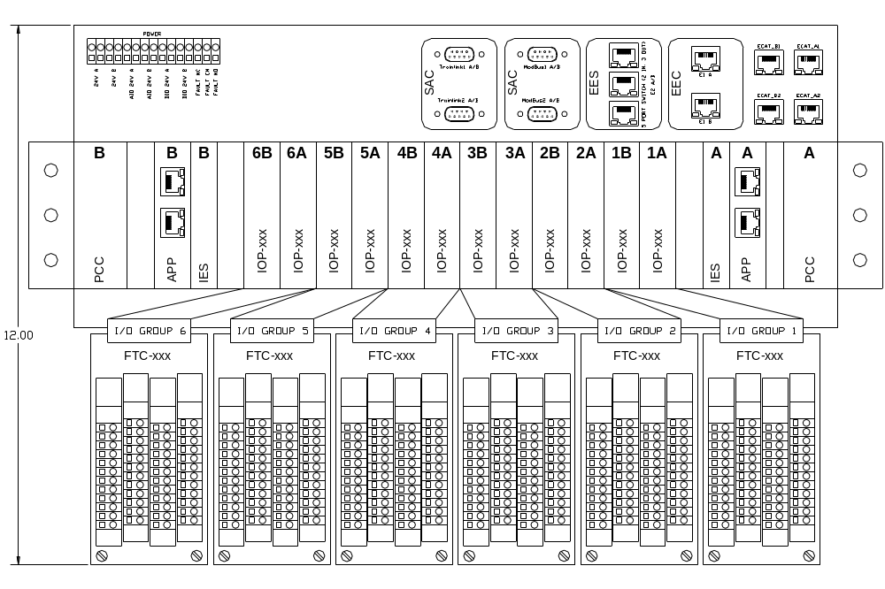
Here is the list of different electrical components in the system and their brief description.

APP
This is the main processing unit in the system. This runs the main application and does monitoring and control of the overall system. There will be a maximum of 2 such cards in an NGP system.

IOP (Digital and Analog)
These are the processors cards which handle digital, analog and frequency IOs. There will be a maximum of 12 (6 pairs) such cards in an NGP system.

IES
This is the EtherCAT switch card used to interface between different APP and IOP modules. There will be a maximum of 2 such cards in an NGP system.

PCC
This is power conversion card. The input power (redundant 24VDC) to the system first comes to this card. This card does the ORing, filtering, protection and other voltage conversion. There will be a maximum of 2 such cards in an NGP system

FTC (Digital and Analog)
These are the field terminal cards, where all the field loads are connected to. These are electrically interfaced to IOP cards.

CAC
These are the set of communication (Ethernet, RS-485) cards used for interface to the external devices.

Backplane
All the above mentioned boards plugged onto the backplane and they communicate to each other through the backplane.

Product Description

The Communication Accessory Cards provide connectivity from the chassis to external devices, typically via Ethernet or RS-485 communications. The communication accessory cards include External TCP/IP Ethernet Card (EEC), External EtherCat Card (ECAT) and the Serial Accessory Card (SAC). They will be designed as pluggable modules onto the backplane along with other cards.

Serial Accessory Card (SAC)

The SAC provides RS485 communication protocol for the system. It provides connectivity from the chassis to the external devices via RS-485 (either full duplex or half duplex, determined by a mechanical switch) communication. The card receives four single ended serial ports, two from APP-A (ports 1A and 2A) and two from APP-B (ports 1B and 2B). The card provides electrical isolation and full duplex RS485 conversion for all the four serial ports. The card shall receive the ‘transmit’ enable signals from the respective APPs, while the receive enable is activated on the SAC by default.

The card accommodates two DB-9 connectors for the external wiring. The redundant ports, port-1A and port-1B shall be connected together on the DB-9 connector side to form port-1. The redundant ports, port-2A and port-2B shall be connected together on the DB-9 connector side to form port-2.

The card shall accommodate two mechanical switches, for switching between full duplex (SAC-MODBUS) and half duplex (SAC-TRAINLINK) modes. The SAC shall provide transient and surge protection for Port 1 A/B and Port 2 A/B.

The SAC shall accommodate hot-swap controller for the hot-swapping of 6.5V received from the backplane. An LDO may be used to convert the 6.5V to 3.3V.

External Ethernet Card (EEC)

The EEC provides the Ethernet communication between the APP and the PC. It receives four Ethernet ports, two from each APP card via the backplane connector and provides four RJ-45 connectors, one for each Ethernet port. The EEC also houses magnetic for each Ethernet port. The magnetic receive the 2.5V (for the centre tap) directly from the corresponding PHYs, placed on the APPs.

ECAT

The ECAT card provides connectivity from the chassis to external devices via EtherCat communication. It receives six EtherCat ports, one each from APP-A and APP-B, and two each from IES-A and IES-B cards. The ECAT card selects between the signals from APP-A and IES-A, as well as the APP-B and IES-B. The selection shall be done using a MUX. The selection is based on the presence or absence off the APP cards. The signals from the APP shall be selected if the APP is present, else the signals from the IES. The card shall provide four circular M12 connectors for four ports(two from IES cards and the other two, either from APP or from the IES).

The card shall provide magnetics for all the four ports. The 2.5V biasing voltage for the magnetic centre tap shall be derived from the 3.3V from the IES cards, on the ECAT card using an LDO.

Bidirectional Traceability of Requirements
Bidirectional traceability of requirements shall be available through Requirements Traceability Matrix, which shall be prepared by Mindteck during the design phase.

Acceptance Criteria
Mindteck shall design, develop and deliver the hardware meeting the functionalities as detailed in section 4.0

Assumptions
    - The RS-485 transceiver shall be placed on the ESC-1 and ESC-2 cards.

Dependencies

    - CAC PCB size and thickness shall be provided by CCC.
    - CCC shall ensure availability of
- About 10% time from an CCC’s representative for addressing queries, reviews and acceptance
- Timely inputs, reviews and approvals
- Assistance in the finalization of all the requirements specification documents
- Validation testing and approval of prototypes

Block Diagram

SAC MODBUS

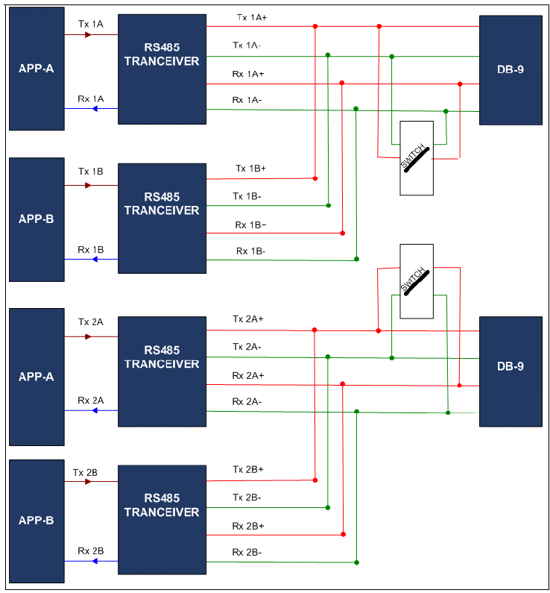

External Ethernet Card

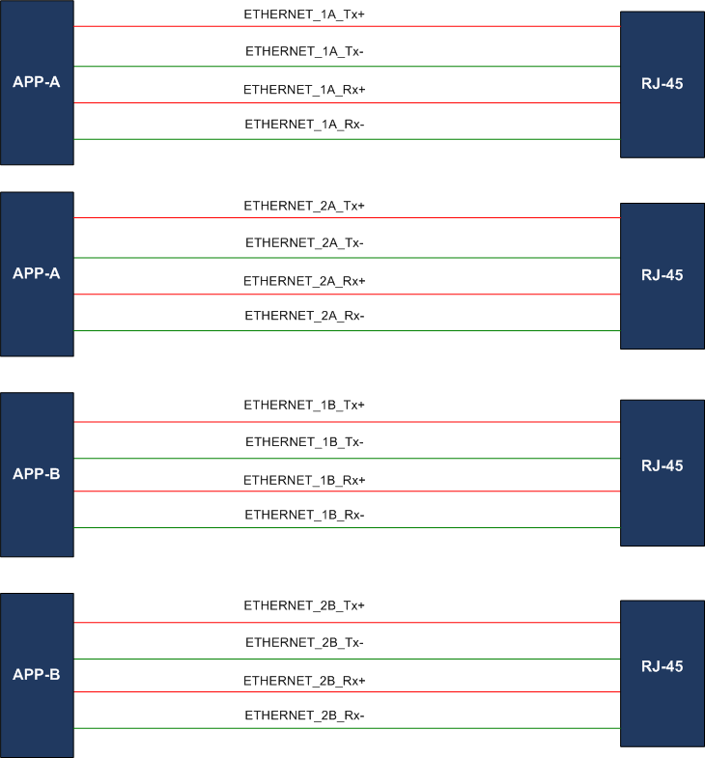

ECAT Card

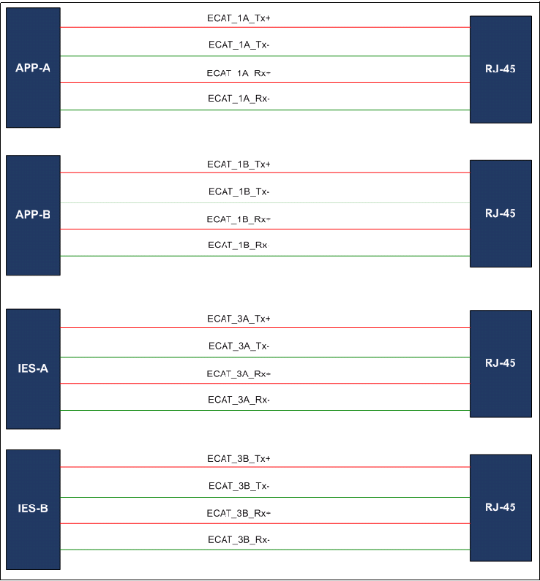

Specific Requirements
Following sections detail out the individual requirements...

Product Functional Requirements

SAC

The SAC card shall provide below functions.

Receives four single ended serial ports, two from the APP-A ( Port1A and 2A) and two from the APP-B ( Port 1B and 2B) via back plane connector

Provides electrical isolation for all the four ports.

Provides RS485 conversion for all the four ports.

Provides independent mechanical switch for each port for switching between full duplex and half duplex operations.

Connects the ports 1A from APP-A and 1B from APP-B together on the RS485 circuit side to form port 1A/B.

Connects the ports 2A from APP-A and 2B from APP-B together on the RS485 circuit side to form port 2A/B.

Provides two output DB-9 connectors , one for port 1A/B and the other for port 2A/B.

Provides transient and surge protection for Port 1 A/B and Port 2 A/B

Supports operation up to 350Kbps.

Provides the hot-swapping feature for the 6.5V from the backplane.

External Ethernet Card

The EEC card shall provide below functions.

Receives four Ethernet ports, two from the APP-A, and two from the APP-B via backplane connector.

Provides RJ-45 connectors for each Ethernet port.

Provides magnetics for all the ports.

ECAT

The ECAT card shall provide below functions.

Receives six EtherCat ports, one each from APP-A and APP-B, and two each from IES-A and IES-B cards and provides four EtherCat output ports.

Provides circular M12 connectors with magnetics for four output port.

Connects two ports (one from each IES) directly to the M12 connectors. The other two M12 connectors receive the signals either from the APP or from the IES selectable using a MUX.

Connects the port from the APP-A/B to the M12 connector if APP-A/B is present.

Connects the port from the IES-A/B to the M12 connector if APP-A/B is not present.

Components

    - All the components shall meet industrial temperature ratings
    - Any BGA parts used shall be Non-RoHS
    - All other parts can be either RoHS or Non-RoHS

Connectors

Board | Make | Part No | Description
SAC | FCI | 10039851-111LF | 54-PIN Air-Max
EEC | FCI | 10039851-111LF | 54-PIN Air-Max
ECAT | FCI | 10039851-111LF | 54-PIN Air-Max

Mechanical Specification

- CAC’s PCB thickness shall be 1.6 mm.
- Form factor of SAC shall be 68.58mm X 68.58mm
- Form factor of EEC and ECAT shall be 68.58mm X 81.28mm.

Material Specification
- The PCB material shall be FR4.. The CACs shall use at least 4 layer board to accommodate all the parts and their dense interconnectivity.
- Components shall be RoHS compliant wherever feasible

Environmental Specification

- For all IC’s and PCB components temperature rating shall be -40°C to +85°C.
- 0 to 60°C Operating range
- Storage temperature shall be -40°C to +85°C.
- Humidity shall be 5 to 95% , non-condensing.

Schematic requirements

Schematic entry shall be done using PADS Logic v-9.0 or higher
Note: The detailed Schematics requirements/ guidelines shall be provided in the separate document.

Layout requirements

Layout shall be done using PADS v-9.0 or higher

Note: The detailed Layout requirements/ guidelines shall be provided in the separate document.

Testing requirements

- Mindteck shall prepare the detailed test reports and presented to CCC for review and approval
- CCC shall conduct acceptance testing on receipt of the PCB assemblies as per agreed schedule

Not in scope

- User manual, tutorial or any other user documentation
- Certification, environmental, ATEX testing, EMI/EMC testing
- Mechanical / enclosure design or prototyping and assembly

Deliverables

Mindteck shall deliver the following hardware deliverables as per the project plan for CCC review and acceptance…

- Hardware Requirements Specifications document
- Hardware Design Document
- CAC schematics design files
- Board Layout files & Gerber files
- CAC Bill of Materials
- Tested prototypes
- Test reports

